Sites that use Texture:



<http://www.gerrenlamson.com/>

* This site uses a textured background which I can only describe as ivory. It makes for a really interesting visual.

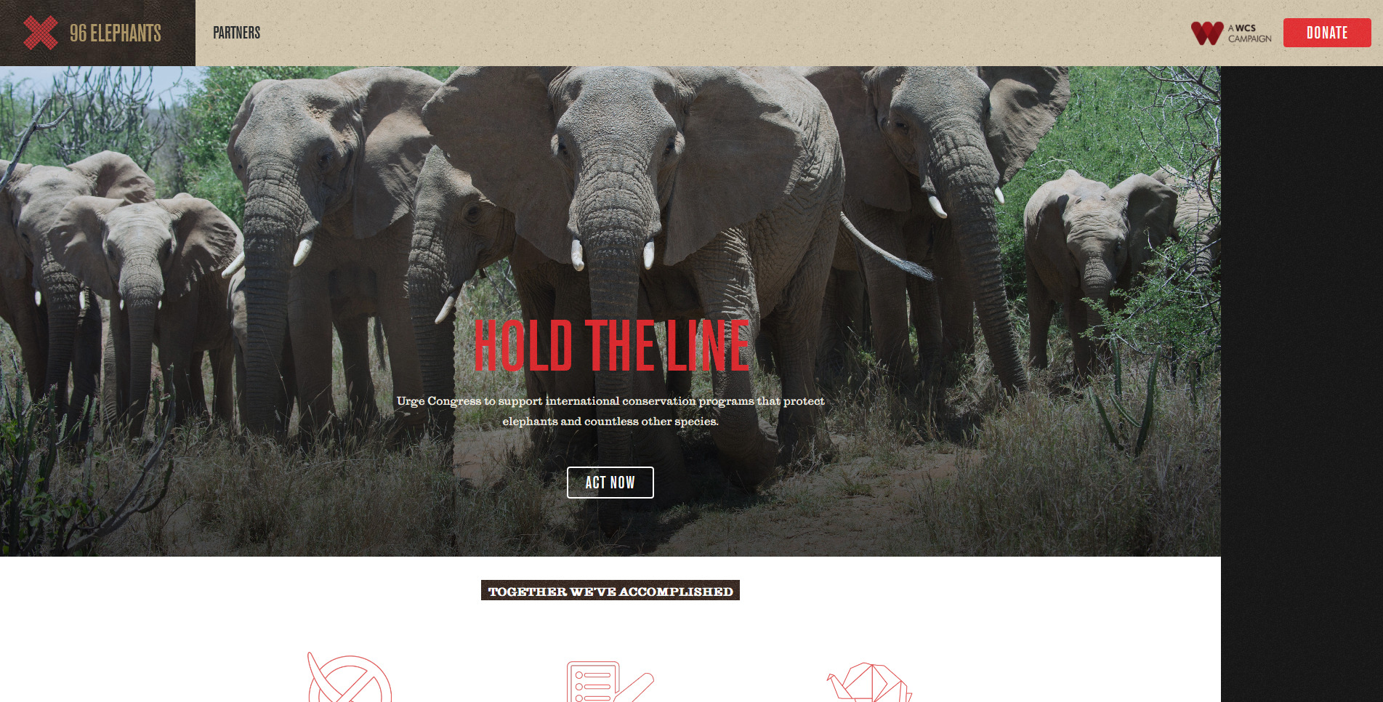

<https://www.wcs.org/96-elephants>

* This site uses a dark texture on the right hand side which gives a static like feel.



<http://zombies.epicmagazine.com/story/5937>

* This design uses some texture on the background photo and also a splattered texture incorporated with text.

Sites that use pattern:

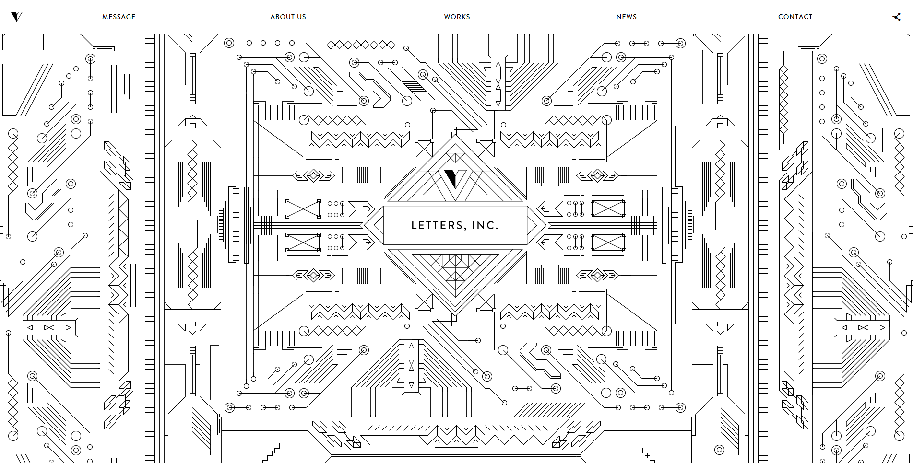

<https://www.letters-inc.jp/>

* This website uses a complex pattern made up of black lines only.



<https://www.gv.com/2014/>

* This website uses a patterned background made up of small animated circles.



<http://www.sociali.st/>

* This site uses a patterned background made up of icons.

Website that uses texture and pattern:

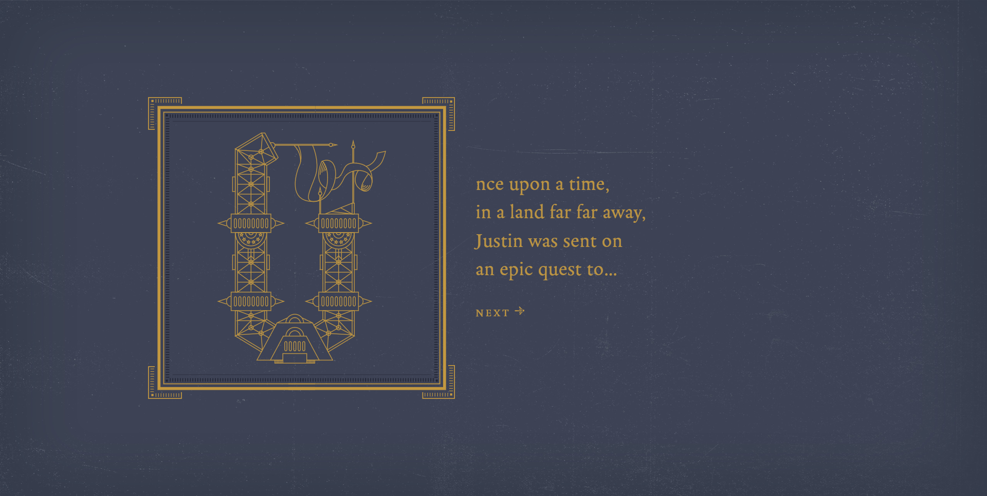

<https://storybook.lesliink.com/>

* This website uses a unique distressed background while also using patterns made up of golden lines.